Explore Compare It Tool to Compare of two files for Forensic Investigation

AIM:

The main aim is to comparison of two files for forensics investigation by COMPARE IT tool

PROCEDURE:
- COMPARE IT is software that displays 2 files side by side, with colored differences sections to simplify analyzing. You can move changes between files with a single mouse click or keystroke, and of course, you have the ability to edit files directly in comparison window.
- It can make colored printout of differences report, exactly as it‟s on the screen. First of all, install the Compare It from the Link given below. http://www.grigsoft.com/wincmp3.htm it is a 1.7 Mb Software package Click on Compare It Tool, It will show a window to select the files to be compared.
- First, select the first file and click on open and then select the second file and click on open.
STEP 1: open the notepad and create a first text file with the extension .txt and savewith a file name
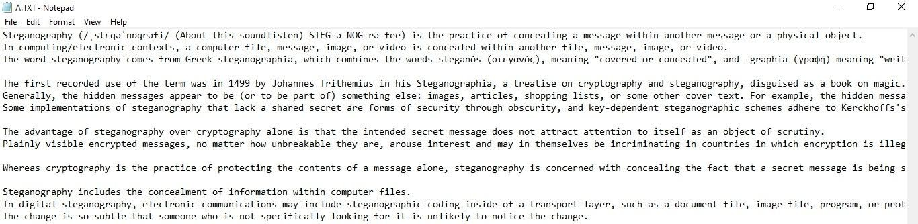
Step 2: create a second text file with the extension .txt
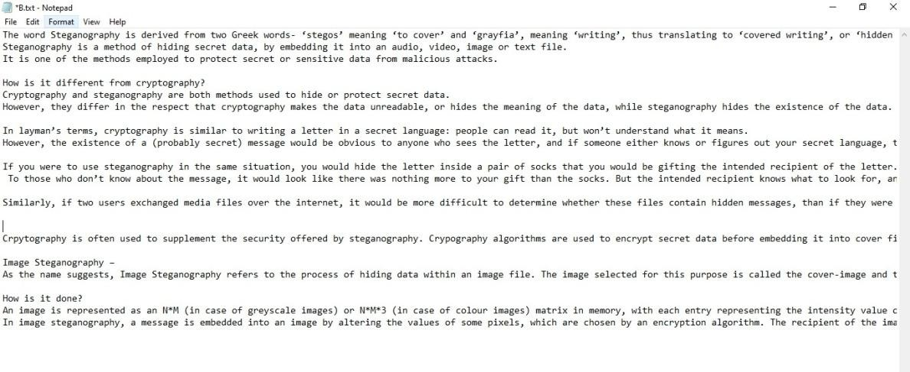

Step 3: Download the compare it tool install the Compare It from the Link given below. http://www.grigsoft.com/wincmp3.htm it is a 1.7 Mb Software package Click on Compare It Tool, It will show a window to select the files to be compared.
Step 4: Upload the first file to the compare it tool
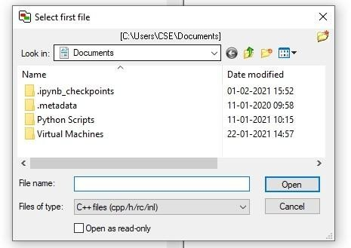
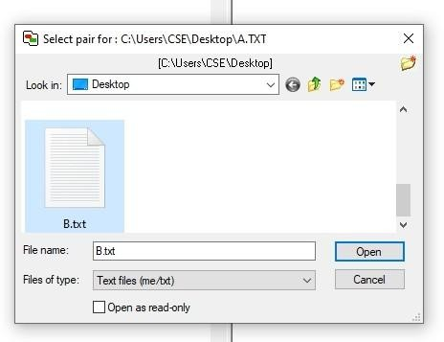
Step 5: upload the second file to the compare it tool

Step 6: Displays 2 files side by side, with colored differences sections to simplify analyzing. You can move changes between files with a single mouse click or keystroke
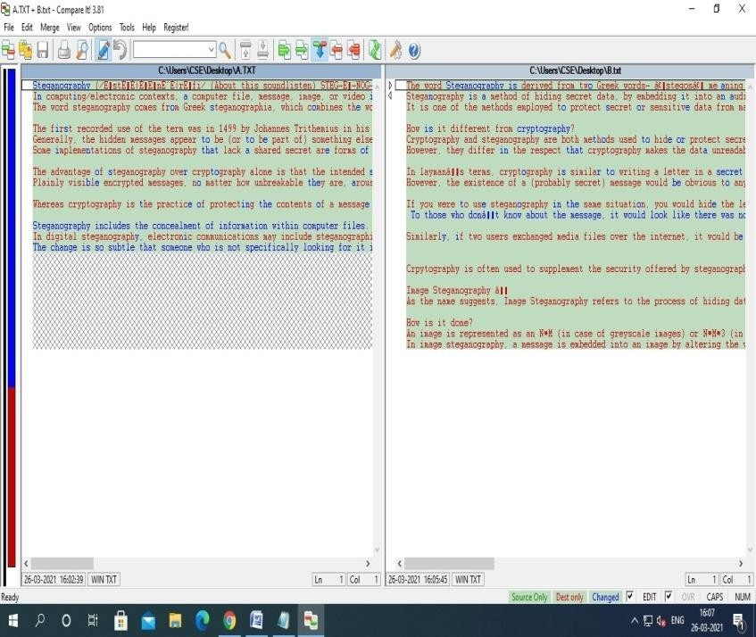
STEP 7: It also gives you Print report of the difference in the file as follows
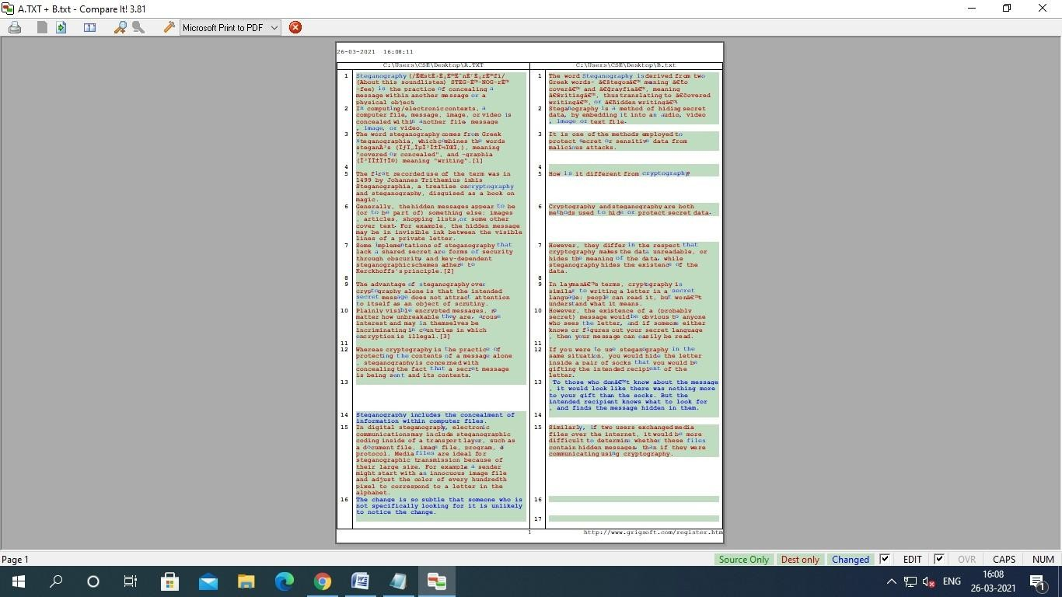

STEP 8: the comparison result is get display.
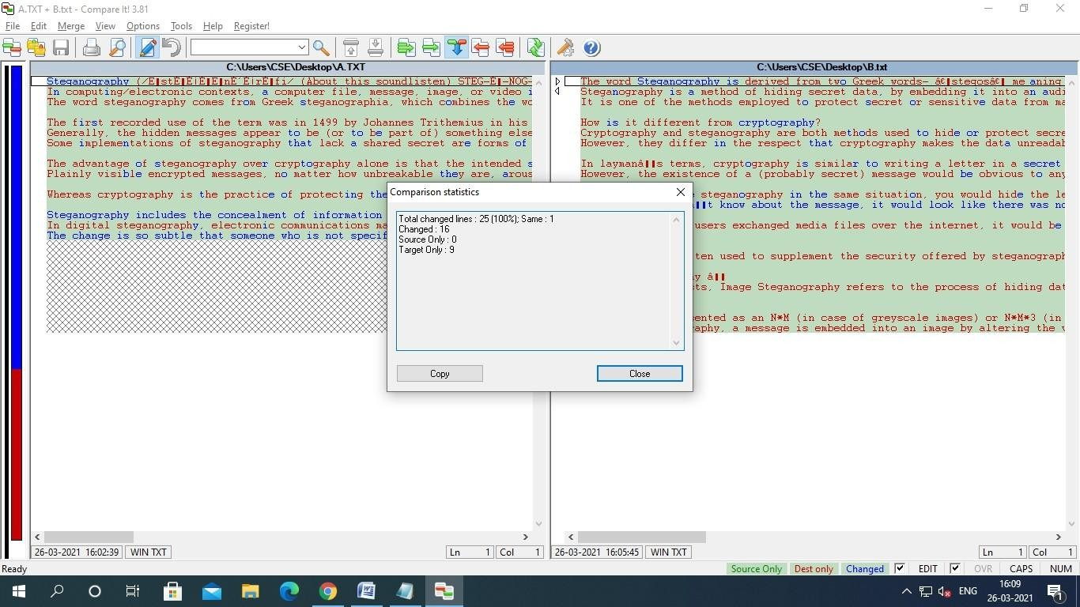

RESULT:
The main aim is to comparison of two files for forensics investigation by COMPARE IT tool is executed successful

Steps to Compare Two Files for Forensic Investigation in Kali Linux
1. Create Two Sample Files
nano file1.txt
(Add some text → save with CTRL+O, exit with CTRL+X)
nano file2.txt
(Add slightly different text → save and exit)
2. Compare Files Using diff
diff file1.txt file2.txt
- This shows line-by-line differences.
- Lines starting with < are from file1, and > are from file2.
3. Use cmp for Byte-Level Comparison
cmp -l file1.txt file2.txt
- Prints the exact byte offset and difference between the files.
- Useful in forensic investigation to detect tampering at a binary level.
4. Use vimdiff for Side-by-Side Colored View
vimdiff file1.txt file2.txt
- Opens both files in Vim with color highlighting for differences.
- Very close to “Compare It” visual style.
Navigation:
- ]c → Jump to next change
- [c → Jump to previous change
- :qa! → Quit both files

5. Use meld (GUI Tool – Similar to Compare It)
If you want a GUI comparison like Compare It:
sudo apt update
sudo apt install meld -y
Then run:
meld file1.txt file2.txt
- Shows side-by-side differences with colored highlights, very close to Compare It’s Windows tool.
- Can also save/print difference reports.
6. Generate a Forensic Report
You can export results to a file:
diff -u file1.txt file2.txt > diff_report.txt
- -u gives a unified diff format, commonly used in forensics.
- You can attach this report as evidence in investigation.

